**What is Power BI?**

Power BI is a business analytics service by Microsoft that provides interactive visualizations and business intelligence capabilities. It allows users to connect to multiple data sources, transform and model data, and create detailed and interactive reports and dashboards. Power BI is designed to enable users, even those with minimal technical expertise, to gain insights from their data and make informed decisions.

**ETL in Power BI**

ETL (Extract, Transform, Load) is a crucial process in Power BI for preparing and transforming data before visualization.

* **Extract:**
  + Connect Power BI to a variety of data sources like Excel, SQL Server, cloud services, etc.
  + Example: Connecting to an Excel file containing sales data.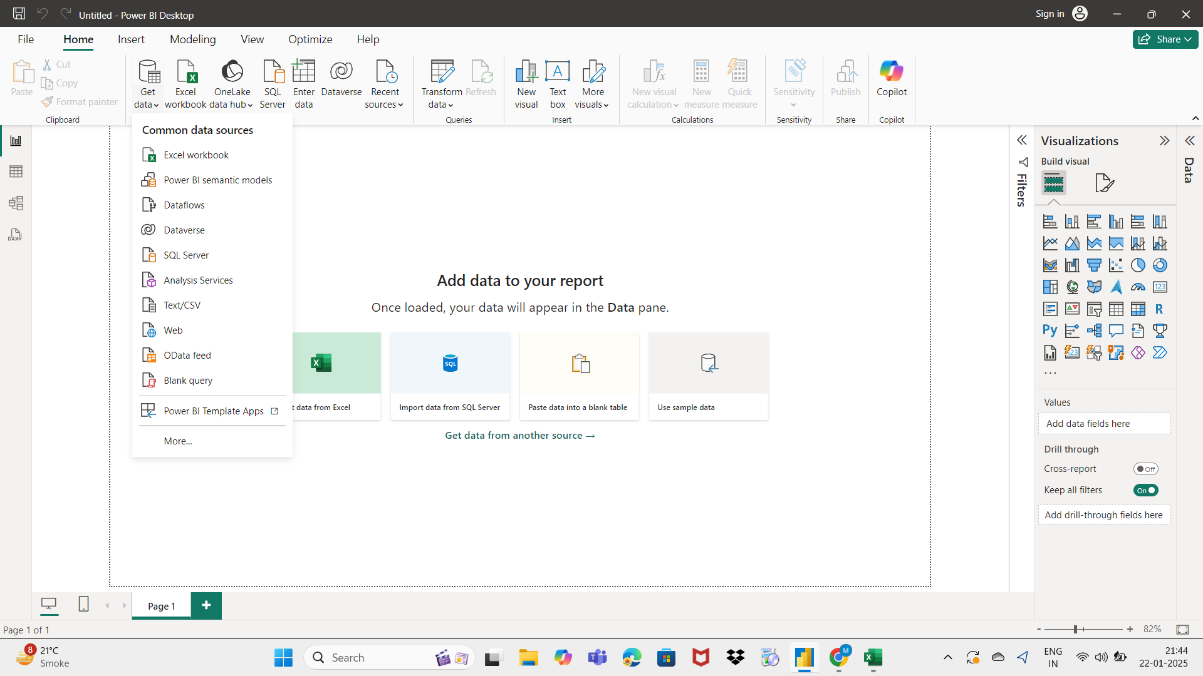
* **Transform:**
  + Use Power Query Editor in Power BI to clean, filter, and shape the data.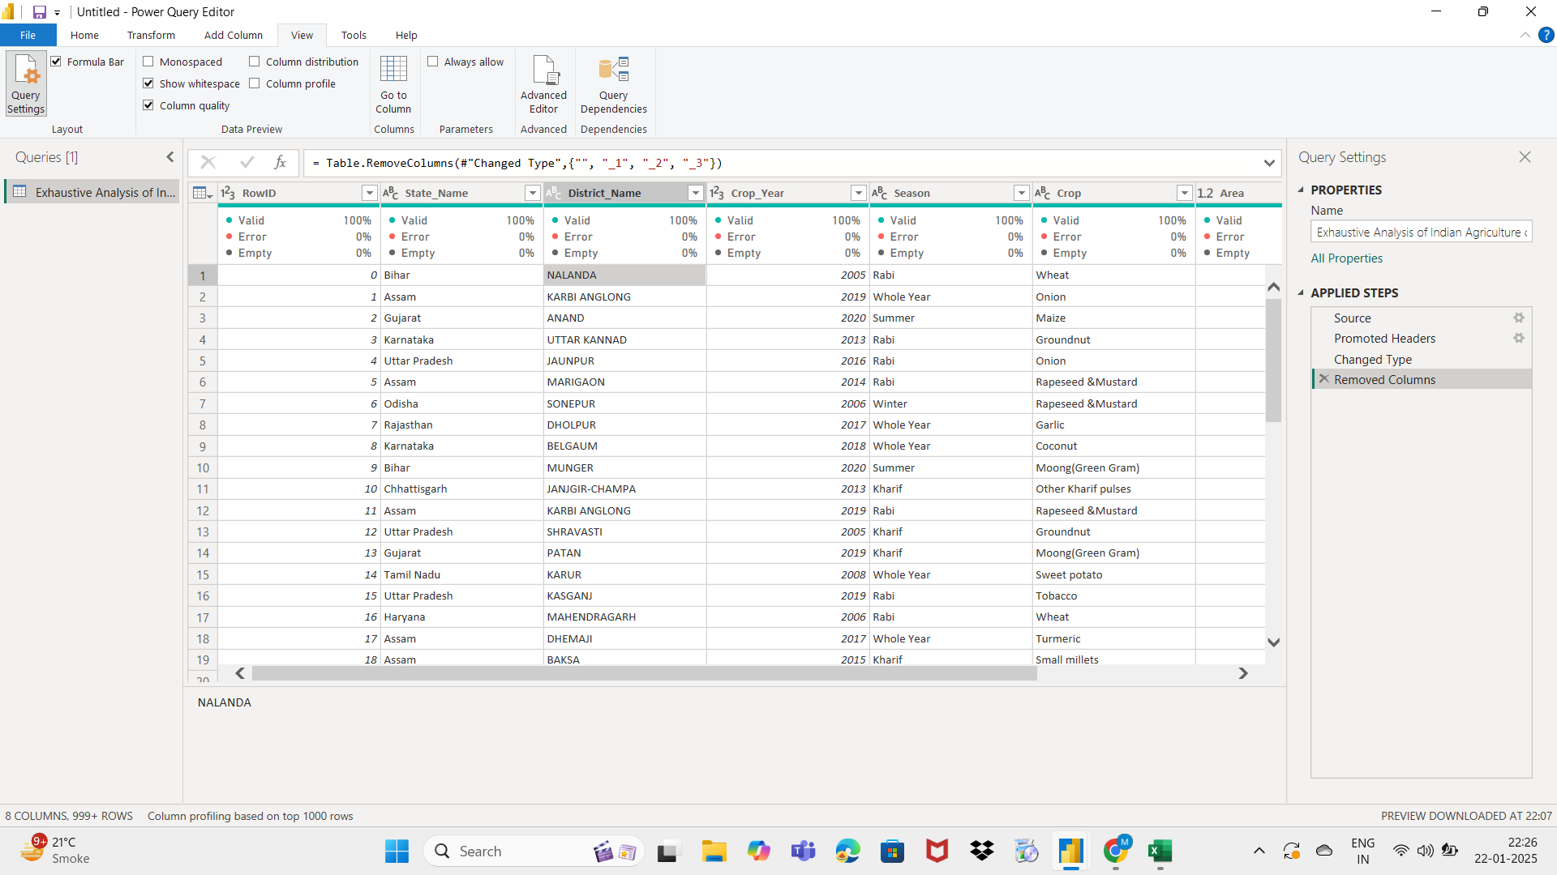
* **Load:**
  + Once the data is cleaned and transformed, load it into Power BI’s data model for visualization.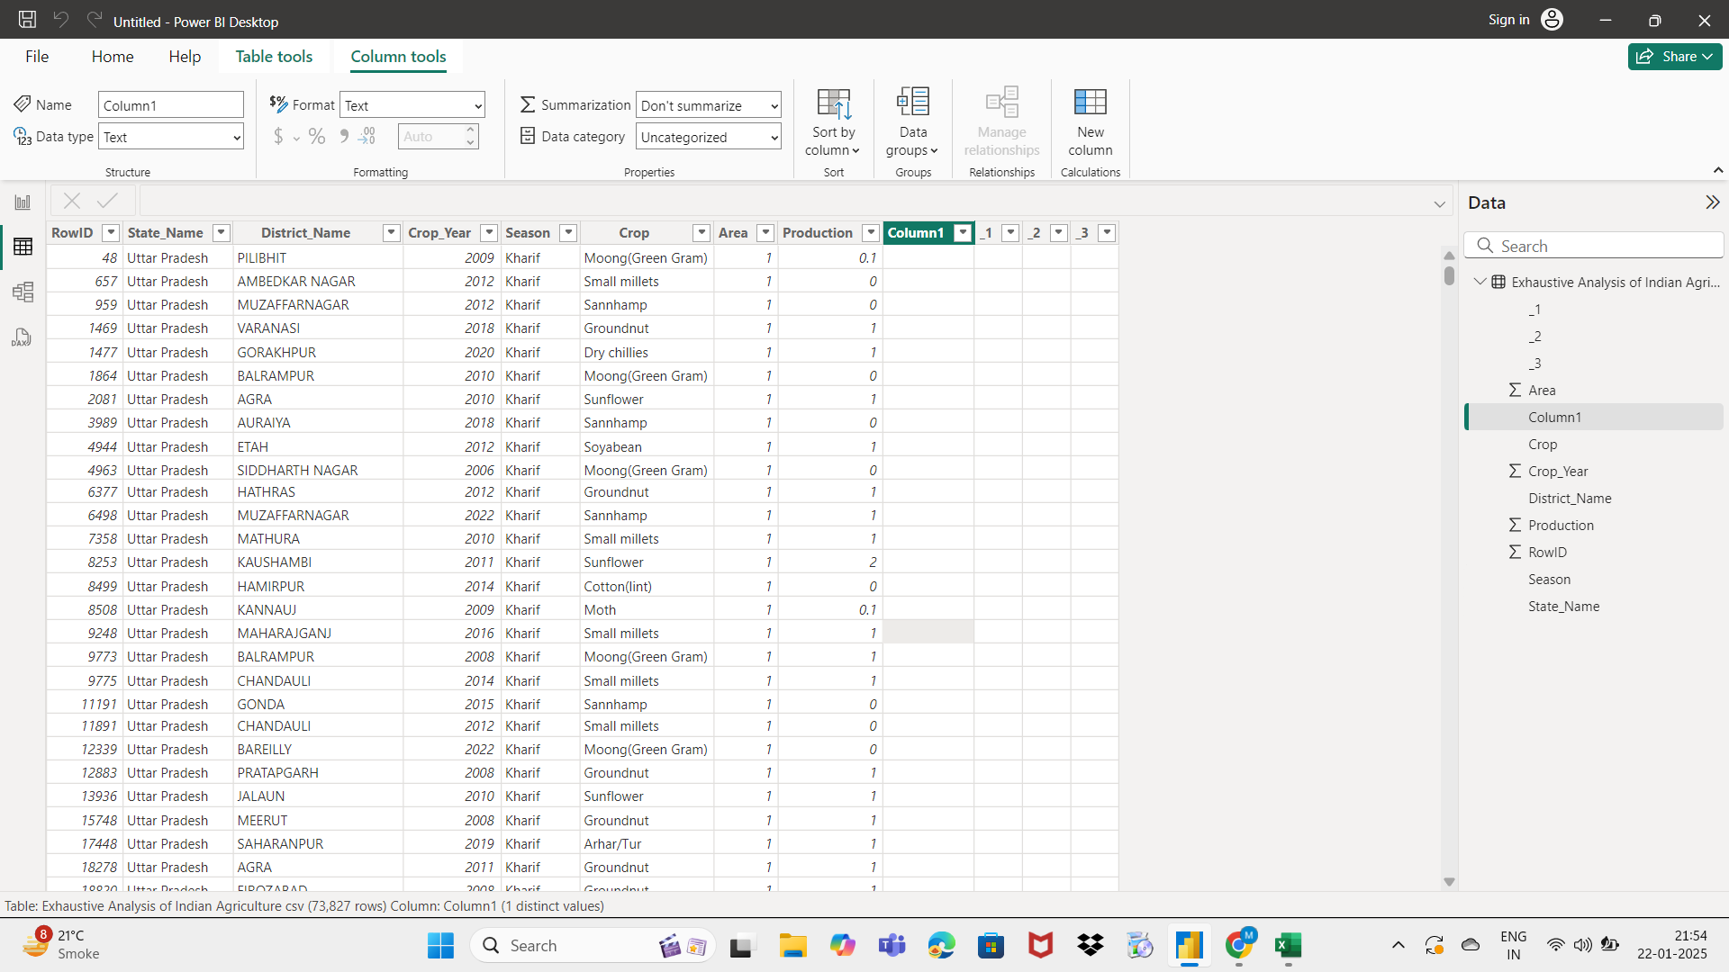

**Views in Power BI:**

The three core views in Power BI are Report View, Data View, and Model View. These views can be found on the left side of the canvas in Power BI Desktop.

**Report View:** This is where you create and interact with visualizations like charts, graphs, and tables. You can drag and drop fields, apply filters, and format the appearance of your reports.

**Data View:** This view allows you to inspect and transform your data. You can view the underlying data tables, edit data, create calculated columns, and clean and prepare your data for analysis.

**Model View:** This view provides a high-level overview of your data model, including tables, columns, relationships, and measures. You can define data relationships, create DAX measures, and manage the overall structure of your data.